**Project Design Phase-I**

**Solution Architecture**

|  |  |
| --- | --- |
| Date | 13 May 2023 |
| Team ID | NM2023TMID 14700 |
| Project Name | Drowsiness detection and alerting system |

**Solution Architecture:**

Solution architecture is a complex process – with many sub-processes – that bridges the gap between business problems and technology solutions. Its goals are to:

* Find the best tech solution to solve existing business problems.
* Describe the structure, characteristics, behaviour, and other aspects of the software to project stakeholders.
* Define features, development phases, and solution requirements.
* Provide specifications according to which the solution is defined, managed, and delivered.

**Example - Solution Architecture Diagram:**

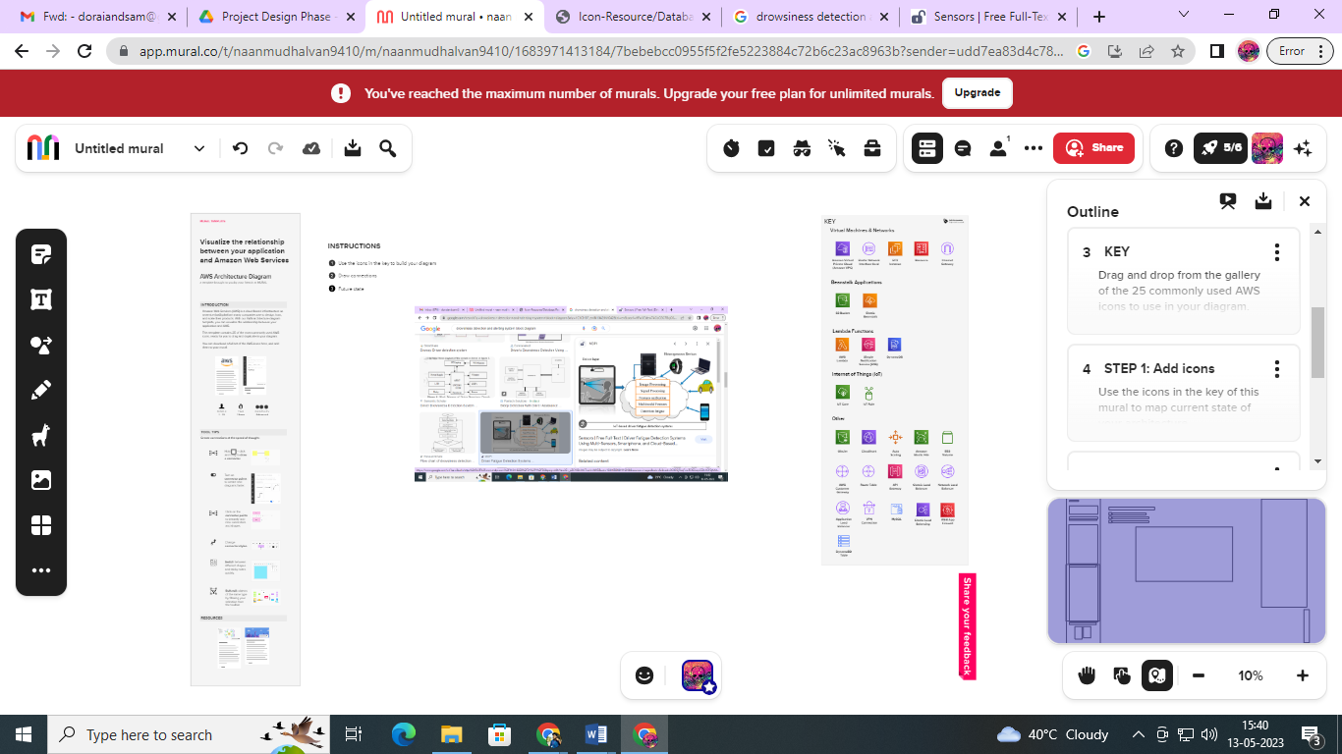

*Figure 1: drowsiness detection and alerting system*

**Reference: https://app.mural.co/t/naanmudhalvan9410/m/naanmudhalvan9410/1683971413184/7bebebcc0955f5f2fe5223884c72b6c23ac8963b?sender=udd7ea83d4c781853a30e0252**